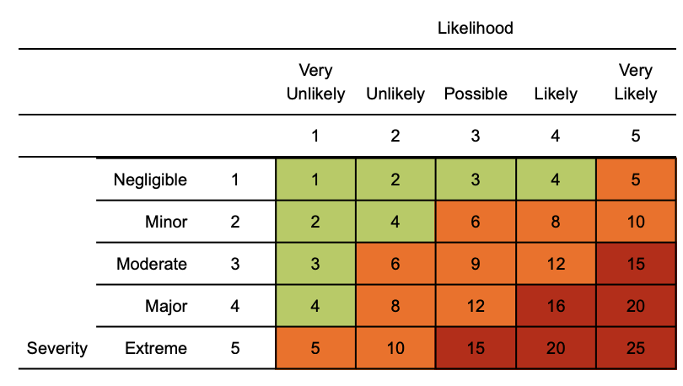
Risk matrix used in risk assessment below
RR = residual risk

Coronavirus (COVID-19) risk assessment

Assessment date: 2nd April 2020
Review date: 2nd October 2020
Version: 1.4

Hazard | Risk | Control measures | RR | Persons at risk
Exposure from others due to:  1) Living with someone with a confirmed case of COVID-19.  2) Have come into close contact (within 2 metres for 15 minutes or more) with a confirmed case of COVID-19.  3) Being advised by a public health agency that contact with a diagnosed case has occurred.  4) Coming in to contact with other member of staff or member of Public with COVID-19 | 4  x  3  =  12 | - To follow government action of self isolation and only to leave house on the following circumstances: for medical reason; to shop for necessary food supplies; for exercise once per day; and for essential works including those deemed ‘key workers’  - Any existing individual risk assessments (disability, young persons or new / expectant mothers) to be reviewed  - Maintain contact with line management and Human Resources (HR) and to follow company policy / guidance.  - Travel is only required for essential travel; reduce the amount of time using public transport and to implement social distancing where possible (2m clearance from persons and not to travel in groups of more than 2 unless it is immediate family)  - To continue following ongoing government guidance  - Stay at home and only attend hospital in an emergency. Do not attend GP surgery and phone NHS line (111) if further advice is required  - Company to ensure extremely vulnerable persons (Solid organ transplant recipients; people with specific cancers: people with cancer who are undergoing active chemotherapy or radical radiotherapy for lung cancer; people with cancers of the blood or bone marrow such as leukaemia, lymphoma or myeloma who are at any stage of treatment; people having immunotherapy or other continuing antibody treatments for cancer; people having other targeted cancer treatments which can affect the immune system, such as protein kinase inhibitors or PARP inhibitors; people who have had bone marrow or stem cell transplants in the last 6 months, or who are still taking immunosuppressive drugs; People with severe respiratory conditions including all cystic fibrosis, severe asthma and severe COPD; People with rare diseases and inborn errors of metabolism that significantly increase the risk of infections (such as SCID, homozygous sickle cell); People on immunosuppression therapies sufficient to significantly increase risk of infection; Women who are pregnant with significant heart disease, congenital or acquired.) are shielding themselves and following their specific medical advice issued to them no later than 29/3/2020  - Follow good NHS hygiene measures at all times  - Avoid all visitors to your home unless they are providing a medical requirement  - Do not approach delivery staff, allow packages to be left on the doorstep  - Do not take any antibiotics as they do not work against viruses. | 4  x  1  =  4 | Individual workers
Suspected case whilst working on site or driving | 4  x  4  =  16 | If a worker develops a high temperature or a persistent cough while at work, they should:  - Return home immediately or to base  - Avoid touching anything  - Cough or sneeze into a tissue and put it in a bin, or if they do not have tissues, cough and sneeze into the crook of their elbow.  - They must then follow the guidance on self-isolation and not return to work until their period of self-isolation has been completed. | 4  x  1  =  4 | Individual workers
General travel including foreign travel | 4  x  4  =  16 | - Do not travel unless you cannot work from home or deemed a key worker – implement teleconferencing for meetings  - Where an individual has recently visited these countries, they should self / home isolate themselves until further notice from the government (lockdown measures continue to apply)  - Please continue to follow any further national government advice provided  - Where an occupational health (OH) service provider has been appointed, please seek additional advice or concerns through this service  - All persons to limit their use of public transport. Where travel is essential, please use private single occupancy where possible | 4  x  1  =  4 | Individual workers
Access / egress to site and or vehicles | 4  x  4  =  16 | Where possible, please consider and implement the following practices:  - Stop all non-essential visitors  - Introduce staggered start and finish times to reduce congestion and contact at all times  - Monitor site access points to enable social distancing – you may need to change the number of access points, either increase to reduce congestion or decrease to enable monitoring  - Remove or disable entry systems that require skin contact e.g. fingerprint scanners  - Require all workers to wash or clean their hands before entering or leaving the site  - Allow plenty of space (two metres) between people waiting to enter site  - Regularly clean common contact surfaces in reception, office, canteen, Drivers Cab, Handrails and Poles and other touch surfaces on your vehicle  - Reduce the number of people in attendance at site inductions and consider holding them outdoors wherever possible  - Drivers should remain in their vehicles if the load will allow it and must wash or clean their hands before unloading goods and materials. | 4  x  1  =  4 | Individual workers
Inclement weather – cold temperature allows disease to survive | 2  x  2  =  4 | - All persons to dress appropriately for the weather  - Welfare facilities provided to shelter from the elements  - Maintain good hygiene measures at all times  - Appropriate respiratory protective equipment (PPE) masks to be considered as last resort | 2  x  1  =  2 | Individual workers
Poor hygiene | 4  x  4  =  16 | - Wash your hands thoroughly and regularly. Use soap and water for at least 20 seconds. Use alcohol-based hand sanitiser if soap and water is not available and hand washing technique to be adopted as directed by NHS  - Avoid touching your face/eyes/nose/mouth with unwashed hands and cover your cough or sneeze with a tissue then throw it in the bin.  - Provide additional hand washing facilities to the usual welfare facilities if a large spread out site or significant numbers of personnel on site  - Regularly clean the hand washing facilities and check soap and sanitiser levels  - Provide suitable and sufficient rubbish bins for hand towels with regular removal and disposal.  - Sites will need extra supplies of soap, hand sanitiser and paper towels and these should be securely stored.  - Restrict the number of people using toilet facilities at any one time e.g. use a welfare attendant Wash hands before and after using the facilities Enhance the cleaning regimes for toilet facilities particularly door handles, locks and the toilet flush Portable toilets should be avoided wherever possible, but where in use these should be cleaned and emptied more frequently  - Ensure the PPE (masks and latex gloves) that has been provided is utilised.  - Ensure the hand gel provided is being utilised. | 4  x  1  =  4 | Individual workers
Canteen - exposure from large numbers of persons | 4  x  4  =  16 | Our canteen is currently closed to our workforce as it was a severe risk given the amount of people touching the appliances. | 4  x  1  =  4 | Individual workers
Vehicle Specific | 4  x  4  =  16 | - Vehicles are professionally sanitised with disinfectant/fumigation machines on a weekly basis  - Drivers are to completely disinfect their vehicle a minimum of twice daily  - Wash Hands Frequently where possible  - Wipe Down all Touch Surfaces as often as possible  - Minimal Contact With Passengers ie only accept the correct fares and only provide information required if requested  - Ensure passengers use the Social Distancing measures put in place on vehicles  - Check Vehicles Regularly ie Every Trip for Rubbish and Remove and Dispose as necessary  - Vehicles are to be fitted with alcohol-free hand sanitiser dispensers. | 4  x  1  =  4 | Individual workers

Training
Please ensure a manager’s brief has been completed alerting to company specific process / procedures
https://www.nhs.uk/conditions/coronavirus-covid-19/
https://www.nhs.uk/conditions/coronavirus-covid-19/self-isolation-advice/
https://www.nhs.uk/conditions/coronavirus-covid-19/advice-for-travellers/
https://www.gov.uk/government/publications/coronavirus-action-plan

Management
- Please ensure all staff are aware of reporting requirements and that all confirmed cases are escalated to your H&S competent person .
- Information notes are to be sent out and any updates communicated in a timely manner to the workforce.
- This must include letting staff know about symptoms and actions the medical professionals are advising people to take.
- A colleague who has been isolated for 14 days cannot return to work until the appropriate ‘fit note’ documentation is provided by their GP/healthcare provider to demonstrate they are now fit to return to work.
- Assessments to be reviewed every 6 months or where significant change has occurred

If in England call NHS on 111, if in Scotland call your GP or NHS 24, If in Wales call 0845 46 47 or 111 or if in Northern Ireland contact 0300 200 7885 where you will be assessed by an appropriate specialist. NHS guidance is that you do not go directly to your GP surgery, community pharmacy or hospital unless an emergency occurs

